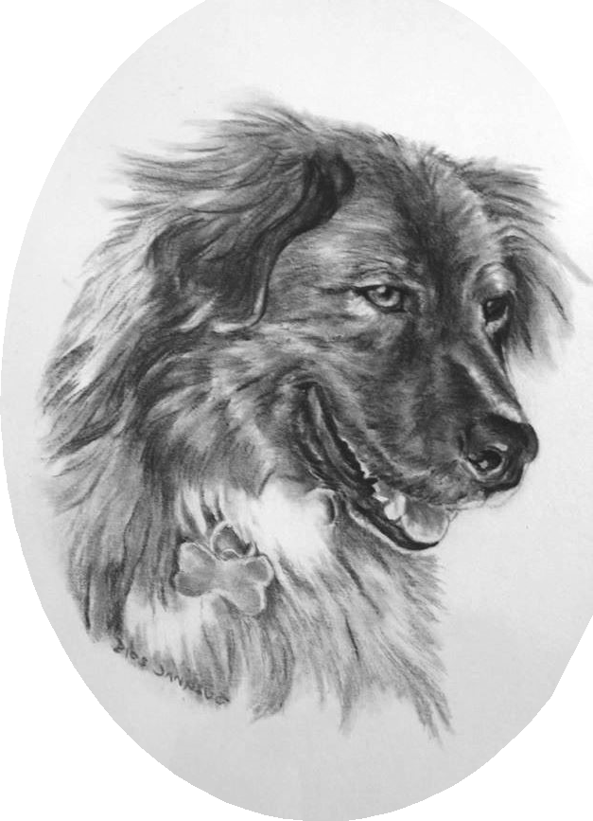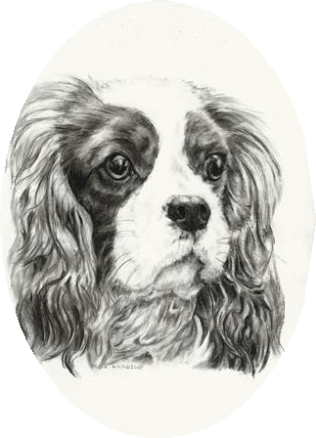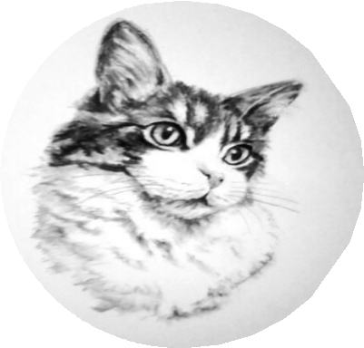Suzanne’s Art
ORDER FOR PARADISE ANIMAL RESCUE

DATE: / _/

NAME: PET NAME / BREED: /
_/

_/ PAGE SIZE : 9x12 ( 1 pet ) $100
9x12 ( 2 pets ) $135

11x14 (3 pets ) $170

A NON-REFUNDABLE DEPOSIT OF $25 DUE AT TIME OF ORDER

Final payment is due before portrait is released. Make checks payable to: Suzanne Shepard * 6164 Metcalf Rd. * Jeddo * MI. * 48032

EMAIL ADDRESS: @_

CONTACT PHONE CELL #

You prefer to receive communications from me via: Cell Email

NOTES: Email your photos / questions to : suzannesart54@gmail.com or you may text your photos / questions to my cell phone : 810-956-7556

********************

My artwork is guaranteed...we work at it until you are happy. I send updated photos of my progress and a preview of the final work for your approval.

You may view other samples of my work on Facebook.com/artworkbysuzanne

No charge for shipping to any address within the U.S.

